**Lab: Association Rules**

1) Download the balance scale data file from moodle

2) Read this file as csv operator and then convert all nominal to binominal attributes.

3) Drag Fp-Growth operator into the process window and link with the create association rule as mentioned below

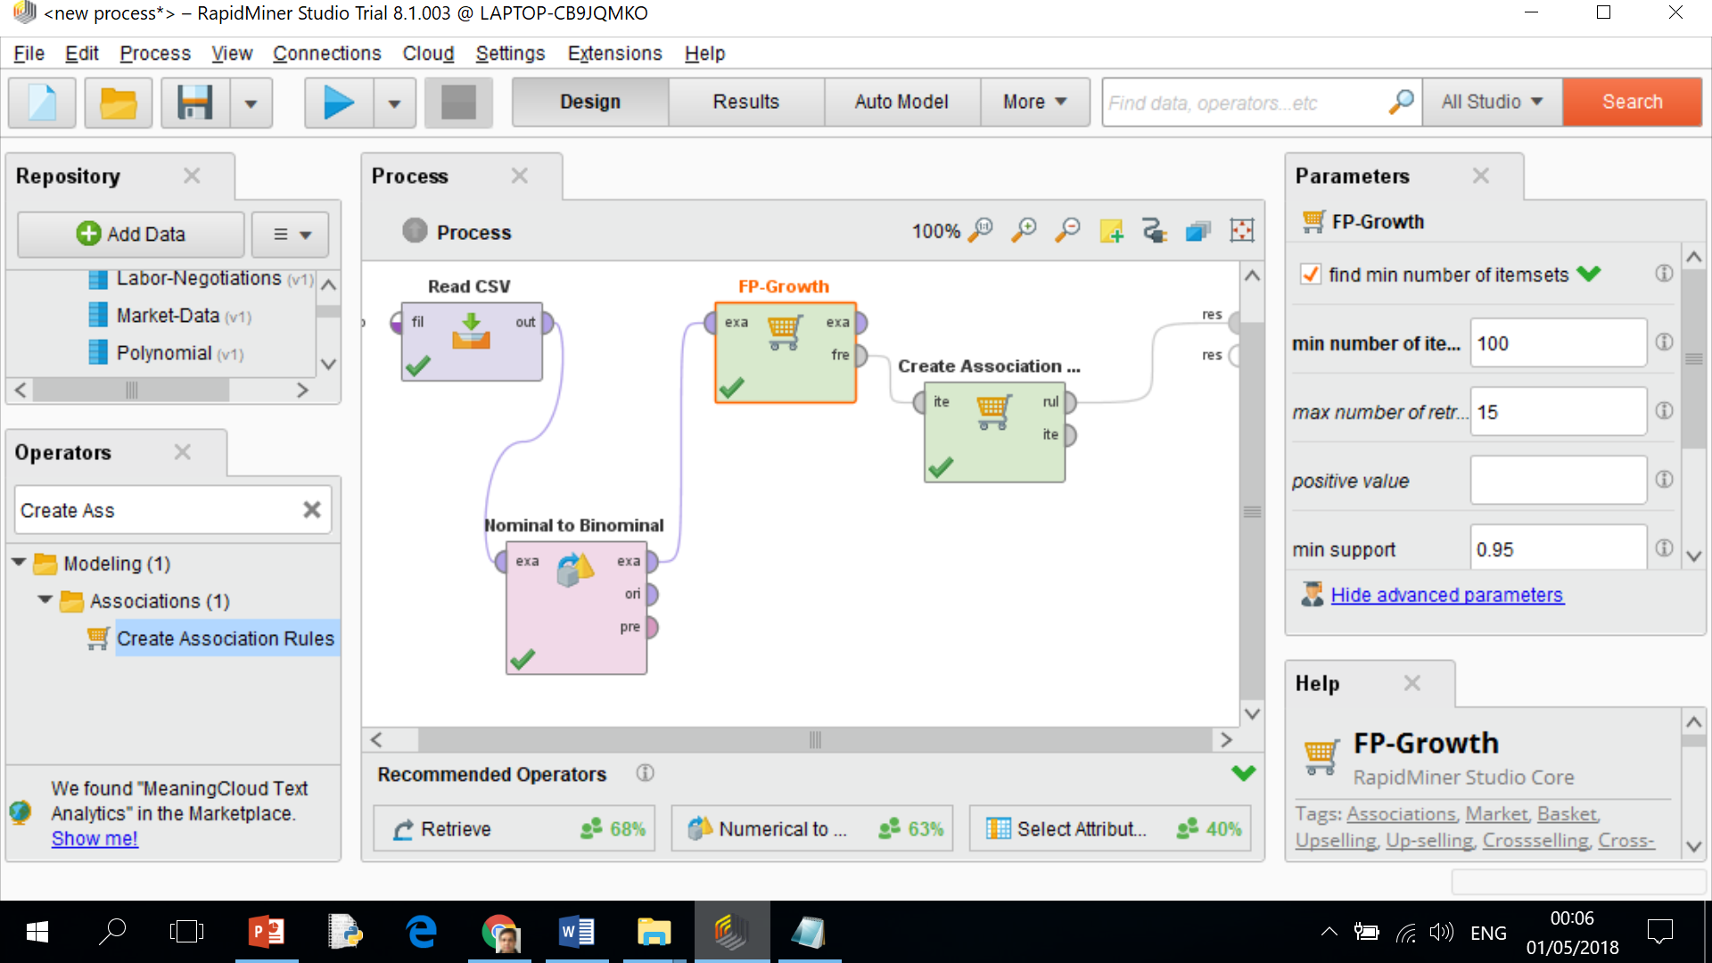

4) When you run the Rapidminer process, you do not find any rule.

5) Adjust the parameter for the operator “Fp growth operator” as mentioned below, Reduce the minimum support value from 0.95 to 0.01 as mentioned below

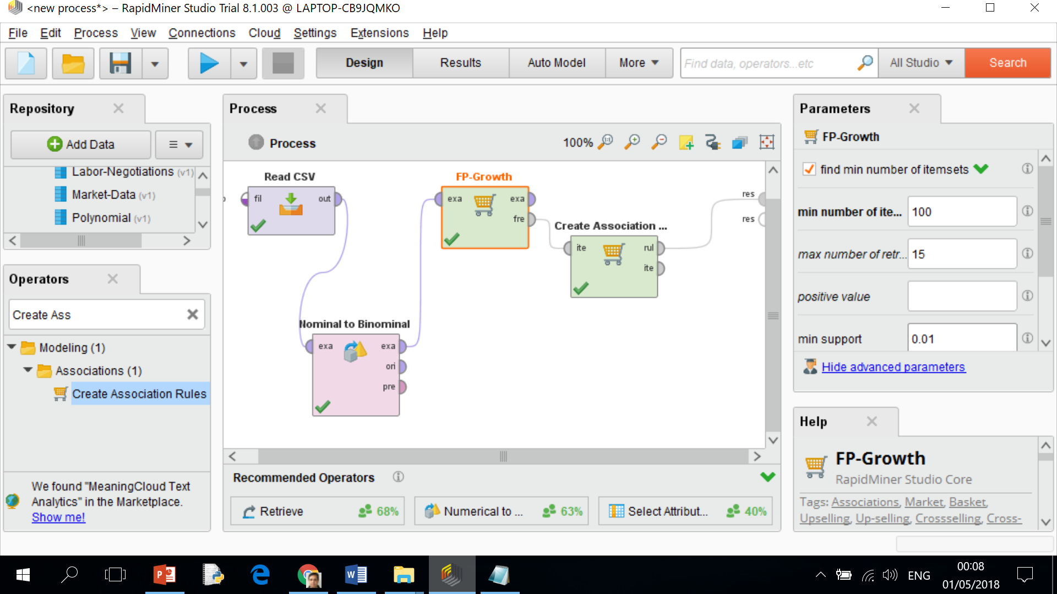

You will find several rules.

6) Reduce the value of minimum support in the case of “Create association rule” from 0.8 to 0.9, you will find smaller number of rules.

7) Now play with various parameters to explore an in-depth understanding of association rule operators.